AP Physics – Fluid Stuff


Matter: Matter is your basic stuff. You probably agonized over what it was in chemistry. Pretty simple though. Matter is just stuff – anything with mass that takes up space. We often keep track of matter via its mass and the volume it occupies.

Density: An important property of matter is density. Density is defined as mass per unit volume. The symbol for density is ρ.

The equation for density is:

Where m is the mass, V is the volume and ρ is the density.

- A rectangular chunk of granite measures 1.5 m by 0.75 m by 2.5 m. How much does the thing weigh?

First, we can get the density of granite for the table that the Physics Kahuna has kindly placed in this very handout. Granite’s density is 2.7 x 10³ kg/m³. Then let’s find the volume of the stone. V = l w h

V = 1.5 m (0.75 m)(2.5 m) V = 2.8125 m³

Solve for the mass:

Find the weight of the stone:

The Physics Kahuna is relatively certain that you probably dabbled around a bit with good old density in your chemistry studies.

Fluids: A fluid is any material that flows and offers little resistance to changing its shape. Essentially, what we’re talking about here, is a gas or liquid. A gas is a collection of very small particles that are rapidly moving around, independently of each other. Gases have an indefinite shape and an indefinite volume.

In a liquid the particles are much closer together and exert attractive forces on each other. The attraction isn't great enough to make the collection rigid, like we would see in a solid, but loose enough so that the particles can move around fairly freely, but not loose enough that they can easily separate. Thus a liquid can flow, but it all stays together. Liquids have a definite volume and an indefinite shape.

Gases can be compressed or expanded - the volume can be easily changed. This is not true for liquids. Liquids are basically incompressible. This is because they are about as close to one another as they can get so squeezing them together doesn’t make much of a difference.

Pressure: There’s a good chance that you have studied pressure in a chemistry class, so we’ll quickly review the important points about it. Firstly, pressure is a scalar quantity.

Pressure ≡ force per unit area.

Mathematically: or

The unit for pressure in the United States is the psi, which stands for pounds per square inch or lb/in². Other common units are the atm, which stands for atmosphere, and inches of mercury. These are the ones that you probably dealt with in chemistry.
The metric system uses the pascal which is abbreviated as Pa.
Naturally we will use the pascal.

- What pressure does a force of 1125 N exert on a surface that measures 2.0 cm by 1.1 cm?

A pascal is one Newton of force acting upon a 1 square meter surface. Turns out that these here pascals is most definitely small – kinda like they’re tiny or something - so the kilopascal (kPa) is commonly used.

Atmospheric pressure is caused by the weight of the air pressing down on the earth's surface. Imagine a column of air that measures one inch by one inch, this means it has a cross sectional area of one square inch. The column soars upward to where the atmosphere ends and the vacuum of space takes over. (This would make it be around 100 000 feet high.) So, imagine weighing this 100 000 foot high by one inch by one inch column on a handy bathroom scale. It would, at sea level, weigh around 14.7 lb.

Its pressure would be:

Table of Density Values for Various Substances

Substance | Density  kg/m³
Alcohol, ethyl | 0.791 x 10³
Aluminum | 2.70 x 10³
Copper | 8.9 x 10³
Gold | 19.3 x 10³
Granite | 2.7 x 10³
Ice | 0.917 x 10³
Brass | 4.70 x 10³
Iron | 7.8 x 10³
Silver | 10.5 x 10³
Lead | 11.3 x 10³
Mercury | 13.6 x 10³
Marble | 2.7 x 10³
Oil | 0.85 x 10³
Quartz | 2.65 x 10³
Rubber | 1.15 x 10³
Seawater | 1.025 x 10³
Styrofoam | 0.10 x 10³
Water | 1.000 x 10³
Wood | 0.50 x 10³
Gases | kg/m³
Air | 1.20
Carbon dioxide | 1.84
Helium | 0.17
Hydrogen | 0.084
Methane | 0.67
Nitrogen | 1.16
Oxygen | 1.33
Steam (100°C) | 1.99

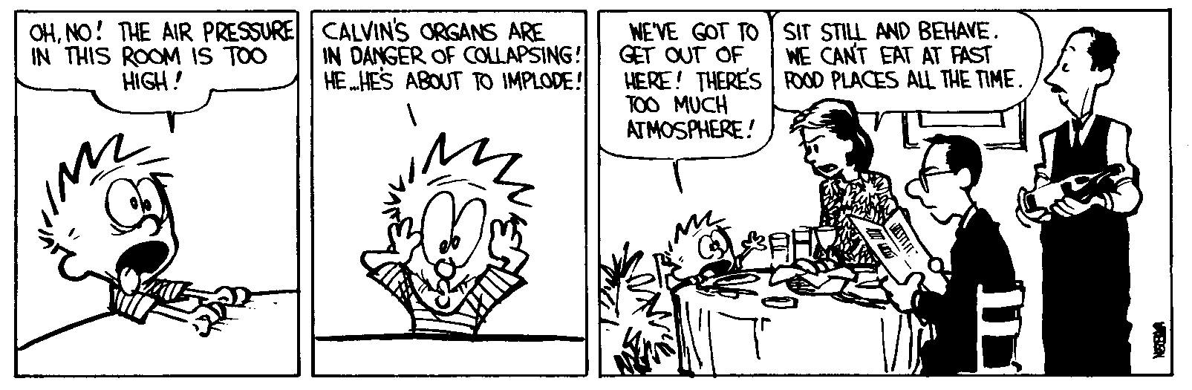
In metric units, a column of air with an area of one square meter weighs 1.013 x 10 ⁵ N (at sea level). Therefore, atmospheric pressure would be 1.013 x 10⁵ Pa or 1.013 x 10² kPa (or 101.3 kPa).

- A 115 lb woman wearing high heel shoes is at a dance. Also attending the dance is a rather large 325 lb man m (maybe a football player or a professional wrestler or some other large man type of profession). You, clumsy as always, trip and fall. The woman and the man both step on one of your hands, placing all their weight on a heel of their respective shoe (which is on your hand). Which would cause the greatest damage? The man's heel measures 3.0 in by 3.5 in and the woman's heel measures 0.50 in by 0.50 in (she’s into those high fashion stiletto high heel type shoes).

The heel that exerts the greatest pressure is the one that will cause the most damage to your hand. First, we calculate the area of each heel.

A = l w A_{w} = 0.50 in(0.50 in) = 0.25 in²

A_{m} = 3.0 in (3.5 in) = 10.5 in²

The woman exerts a pressure that is seventeen times greater than that of the man. So avoid high heel wearing women when you are lying about on the deck at fancy dances!

- The atmospheric pressure is 1.013 x 10² kPa. What force does it exert on the top of a desk that measures 152 cm by 76 cm?

A = l w A = 1.52 m (0.76 m) A = 1.155 m²

The study of liquids at rest is called hydrostatics.

If you dive under water, as you get deeper, the weight of the water above you exerts pressure on you. As you go deeper, the pressure increases - more water above you, right? The pressure increases by roughly 1 atm for every 32 feet of depth.

How does the pressure act on you?

The way a force acts on a solid is different than the way it acts on a fluid. Since a solid is a rigid body, the force does not change its shape. The force mostly tries to move the object. A liquid cannot sustain a force in this way. Push on the water in a wading pool and you makes a splash – you make the water flow. If the fluid is restrained so that it can’t flow, and a force is exerted on it, the force will increase the internal pressure of the fluid. The pressure exerted on a fluid in a closed vessel is transmitted throughout the fluid and pushes at right angles to all surfaces that it touches. This is called Pascal's Principle.
Pascal’s principle ≡ The force exerted by a fluid on the walls of its container always acts perpendicular to the walls.

When you are under water the water’s pressure pushes in on you from all sides. The force is perpendicular to your body. The clever drawing to the right shows you some of the force vectors acting on the intrepid snorkel diver. (Although she appears to have lost her snorkel.)

The Barometer: The barometer is a device used to measure air pressure.

If you fill a glass with water in a tub and then invert the glass and partially pull it out, the water will stay in the glass. Why?
The weight of the atmosphere pushes down on the surface of the water – the old atmospheric pressure. The water in the tub is confined so the pressure exerted on the surface is transmitted throughout the liquid. The pressure exerts a force perpendicular to the surfaces in the tub and in the glass. So the water in the glass is pushed upward.

The water in the glass wants to run out because of its weight, so it exerts a force throughout the water that acts perpendicular to the various surfaces. It acts on the water surface, pushing it up. This can be seen in the lovely drawing above.
The effect of this is that the two sets of forces cancel out. The water wants to run out of the glass and raise the surface in the tub but the weight of the air pushes down and that force is greater, so the water is pushed up the glass. We end up with a static column of water in the glass.

This is how a barometer works. The atmosphere can support a tall column of water. If we have a column of air that has a cross sectional area of one square meter, it weighs 1.013 x 10⁵ N. It turns out that it can support a column of water of the same cross sectional area so long as the water weighs the same or less than the air. For sea level, this works out to about a ten-meter tall column. This is about 32 feet.

Minor variations in the atmospheric pressure cause the water column height to vary slightly. The height of the column could then tell you what the atmospheric pressure is.

Well, barometers don’t use no water, instead they use mercury. Why?
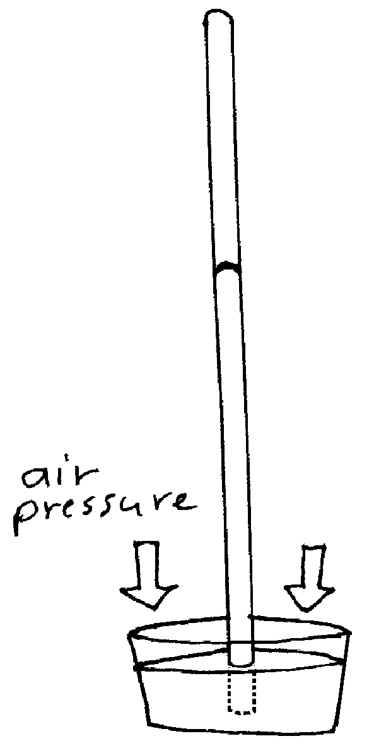
Mercury is very dense – about 13.5 times denser than water. So a barometer using mercury as the working fluid doesn’t have to be as tall as a water barometer. It turns out that at sea level, the column of mercury will be around 760 mm high (which is around 30 inches). 30 inches high is a lot more handy and practical than 32 feet.

So how do you make a barometer? You takes you a glass tube, closed at one end, that is around 80 cm in length or so and fill the thing with mercury. Plug up the open end and turn the whole thing upside down. The open end, now on the bottom is placed into a reservoir of mercury and the plug is removed. The mercury will run out of the tube until the weight of the mercury is equal to the weight of the air column. The area above the mercury in the tube is essentially a vacuum (it will have a small amount of mercury vapor that has evaporated, but there isn’t much vapor in there).

A common pressure unit when using barometers is the height of the mercury column. At sea level, this is around 760 mm or 76 cm. In America we use inches. The height of the mercury column at sea level is around 29 inches. Thus, when you hear the weather report the weather person might say that the barometric pressure is 29.2 inches of mercury. In Gillette the atmospheric pressure is less because of the altitude. The meteorologists give us a relative air pressure. They pretend that the normal mercury column height is 30 inches and give us readings based on that.

Dear Doctor Science,
Why is barometric pressure given in inches of mercury?
-- Hugh Grant from Ardmore, PA

Dr. Science responds:
Back in the 1840's, when barometric pressure was first discovered, it was considered vulgar to make a direct statement about the laws of nature. The phases of the moon were called "Lunar Melancholic Waning" and even rainfall was referred to as "The Lamentations of the Firmament." Everyone was a long-winded poet, including Gilbert Shelton, the English amateur meteorologist, who coined the metaphor "Mercuric Altitude" to describe his mental condition just before a storm. Today, even when half the nation is on anti-depressants, we continue this proud tradition.

Back to Barometers: Barometers are useful in forecasting the weather. The rule of thumb is that falling air pressure means bad weather, and rising air pressure means good weather. A steady air pressure also means good weather. This is because weather is caused by huge, moving masses of air which have different pressures. So pressure changes signal the movement of air masses that have different temperatures which means weather. A low pressure means that weather is coming towards you. A high pressure means that the weather is somewhere else, but not where you are.

Today, any device that measures air pressure is called a barometer, so not all instruments use mercury columns. Aneroid barometers use little bellows (like accordions have) to measure the air pressure.

Pressure and Density: As mentioned before, when one is swimming under water, the deeper you go, the greater the pressure you are exposed to.

The weight of the water above you is:

Recall that density, ρ, is equal to:

so, Plug this in for mass:

Volume is equal to the area multiplied by the height, or:

Plug in A h for V and you get:

Pressure is: We can substitute ρAgh for F since the weight is the force

so

Thus the pressure in a fluid column can be found using this equation:

This equation is provided you in a slightly different form for the AP Physics Test. It looks like this:

Here the only new thing is - this simply stands for the initial pressure.

The pressure is proportional only to the depth and density of the fluid. The shape of the container or the object has no effect on pressure.

- What is the pressure exerted by water at a depth of 45.0 m?

Unit wise, you have a kg m/s² (which is a N) over a m², which makes the thing a Pascal.

